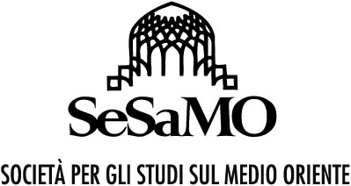
14th SeSaMO Conference
Paths of Resistance in the Middle East and North Africa
University of Turin (Italy)
31 January–2 February 2019

TITLE AND NUMBER OF THE PANEL: ………………….………….

TITLE OF THE PAPER: ……………..
ABSTRACT:
(250 words max, font: calibri 10)

ACADEMIC PROFILE:
(50 words max for each profile, font: calibri 10)

EMAIL ADDRESS: …………………………………….

